QUANTITATIVE DERTERMINATION IN COMPARISION OF
RAMIPRIL IN PURE FORM WITH OTHER PHARMACEUTICAL DOSAGE FORM BY USING RP – HPLC

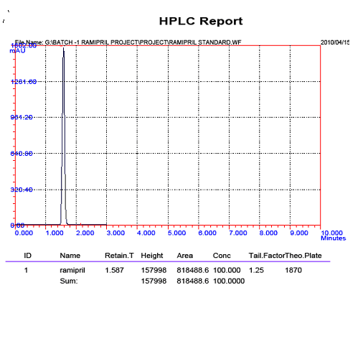
Fig no: 1- standard Ramipril

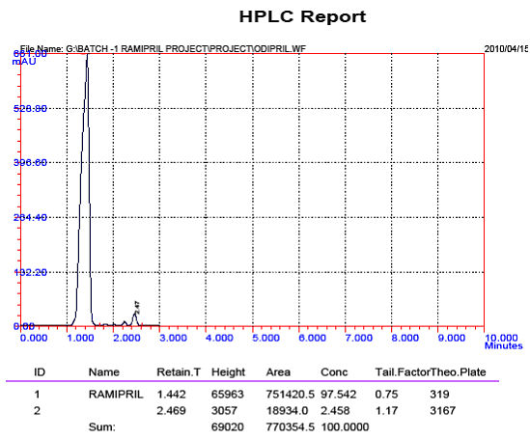
Fig no: 2 – sample 1-odopril
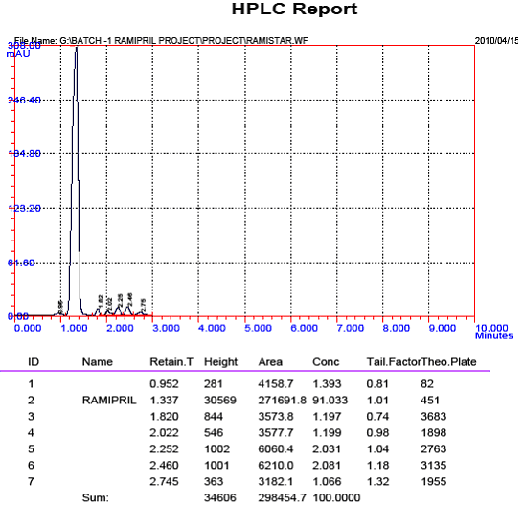
Fig no: 3 – Ramistar sample
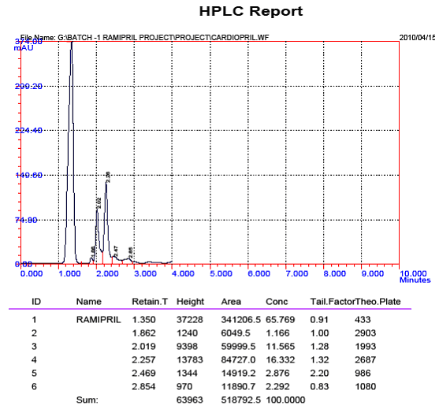

Fig no: 4 – cardiopril sample
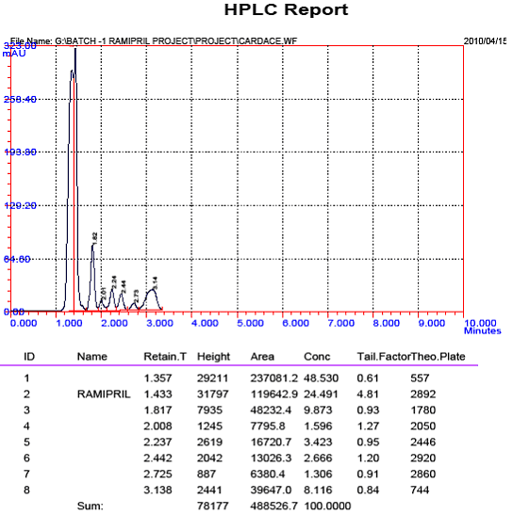
Fig no: 5 – cardace sample

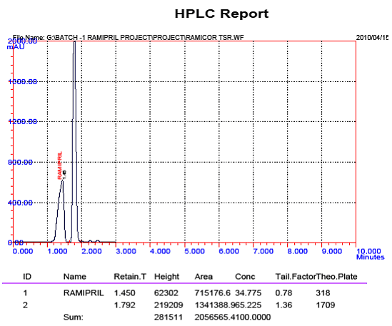

Fig no: 6 – Ramicor sample

