**Development and Validation of HPTLC Method for Simultaneous Estimation of Atorvastatin Calcium and Olmesartan Medoxomil in Tablet Dosage Form**



**Figure 1: structure of Atorvastatin calcium (AT)**



Figure 2: Structure of olmesartan medoxomil (OLM)

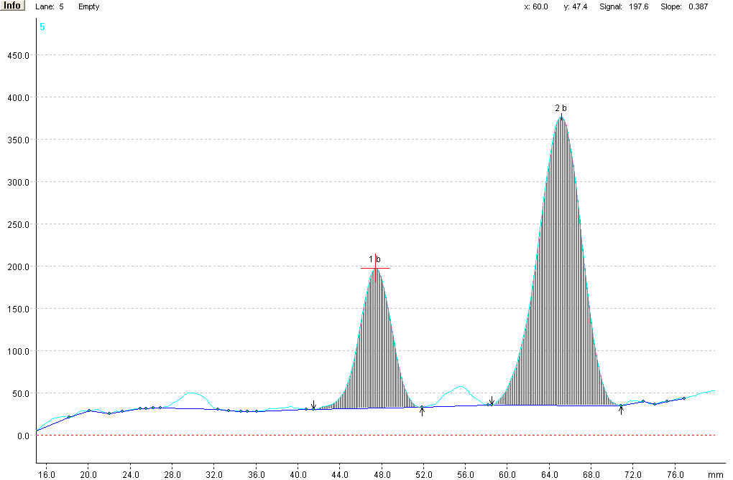

Figure 3: Representive densitogram of atorvastatin and olmesartan at Rf value 0.50 and 0.76

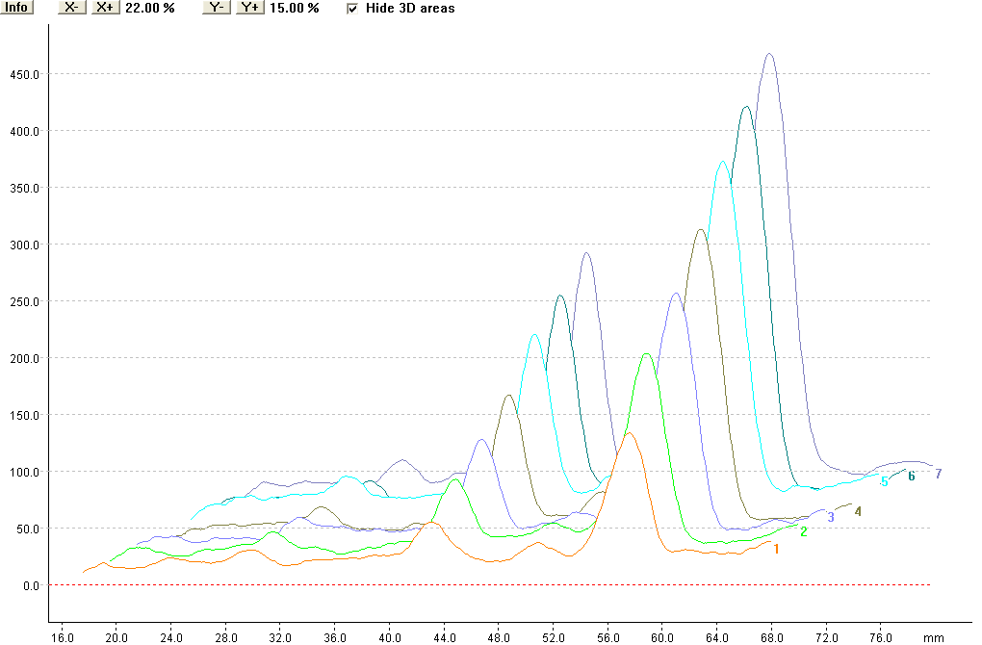

Figure 4: overlay 3D chromatogram of linearity range.