**SIMULTANEOUS DETERMINATION AND VALIDATION OF TELMISARTAN AND RAMIPRIL IN PHARMACEUTICAL DOSAGE FORM BY RP – HPLC AND HPTLC**

**Schematic Representation of HPLC**

**Solvent container ⎯ Pump ­⎯ Damping unit ⎯ Injection port**

**|**

**Column**

**|**

**Recorder ⎯ Detector**

**|**

**Effluent**

**Schematic procedure for HPTLC**

The various steps involved in HPTLC are schematically represented as follows:

Sample and standard

Preparation

Layer pre-washing

Selection of chromatographic layer

Layer pre-conditioning

Application of sample and standard

Chromatographic development

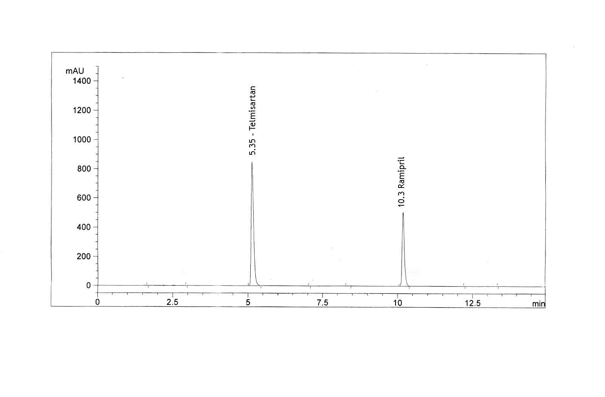

Scanning and documentation of chromatoplate

Detection

**Chromatogram of Telmisartan & Ramipril Formulation**

### 

### Linearity of Telmisartan



**Linearity of Ramipril**

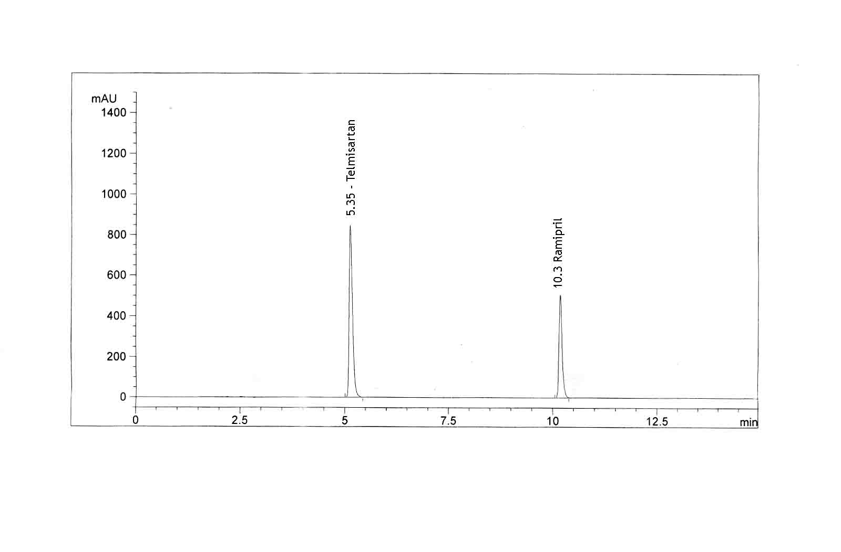

**Chromatogram of Recovery Studies at 5% Level**

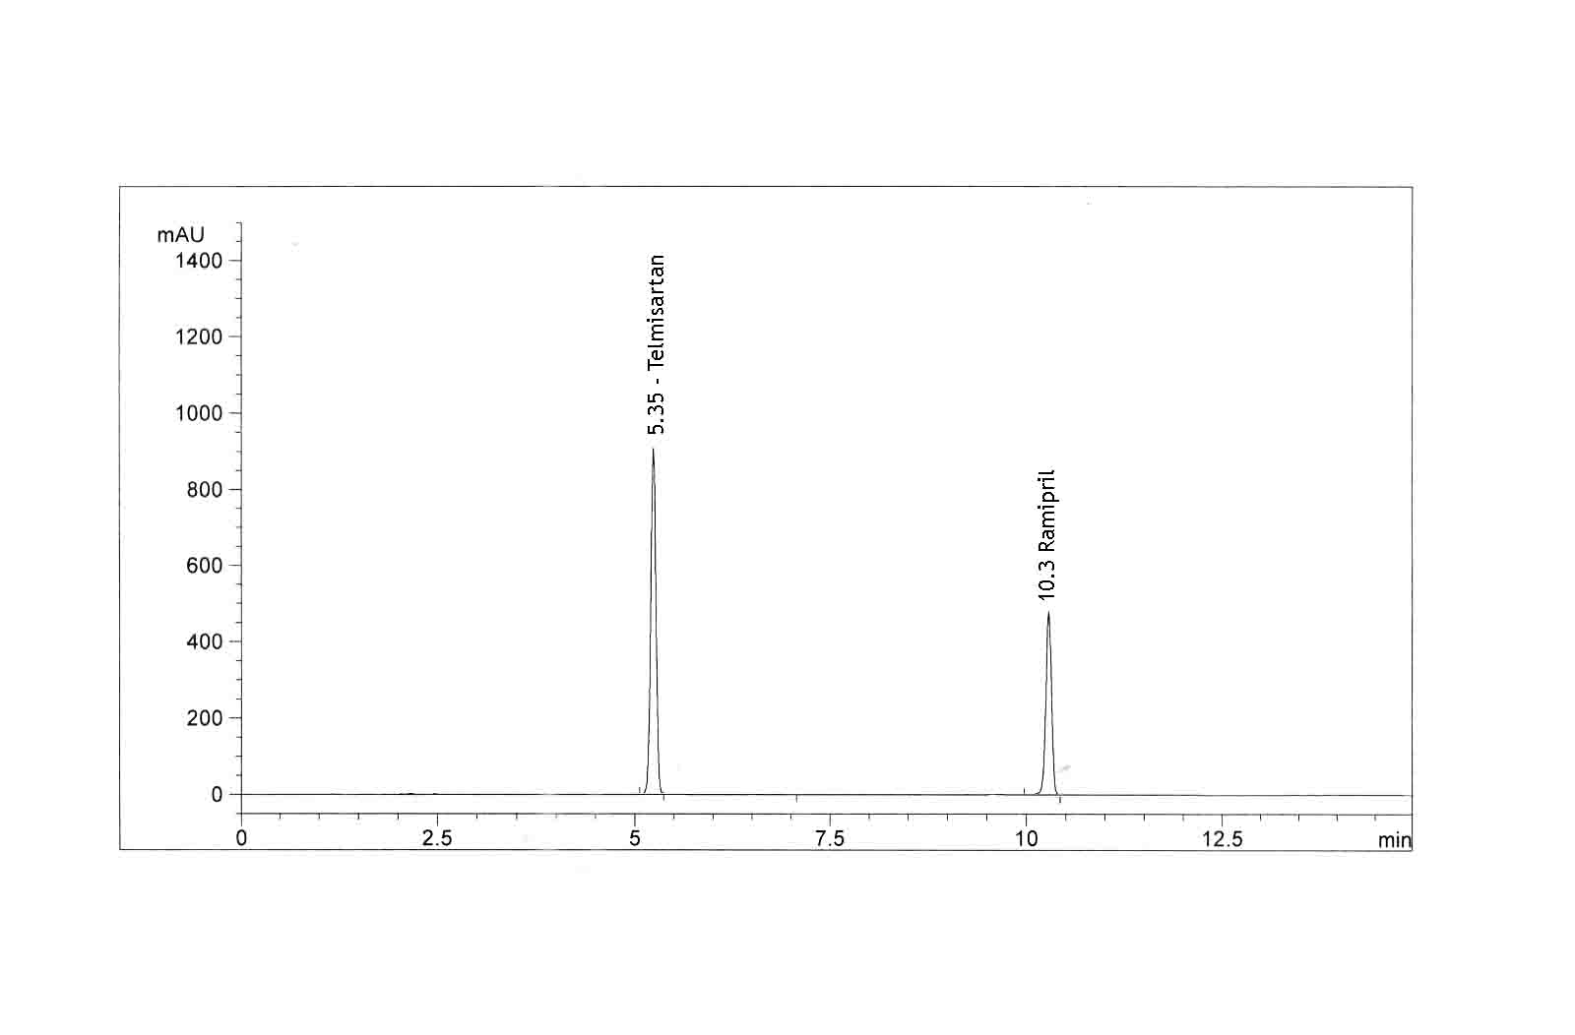

**Chromatogram of Recovery Studies at 10% Level**

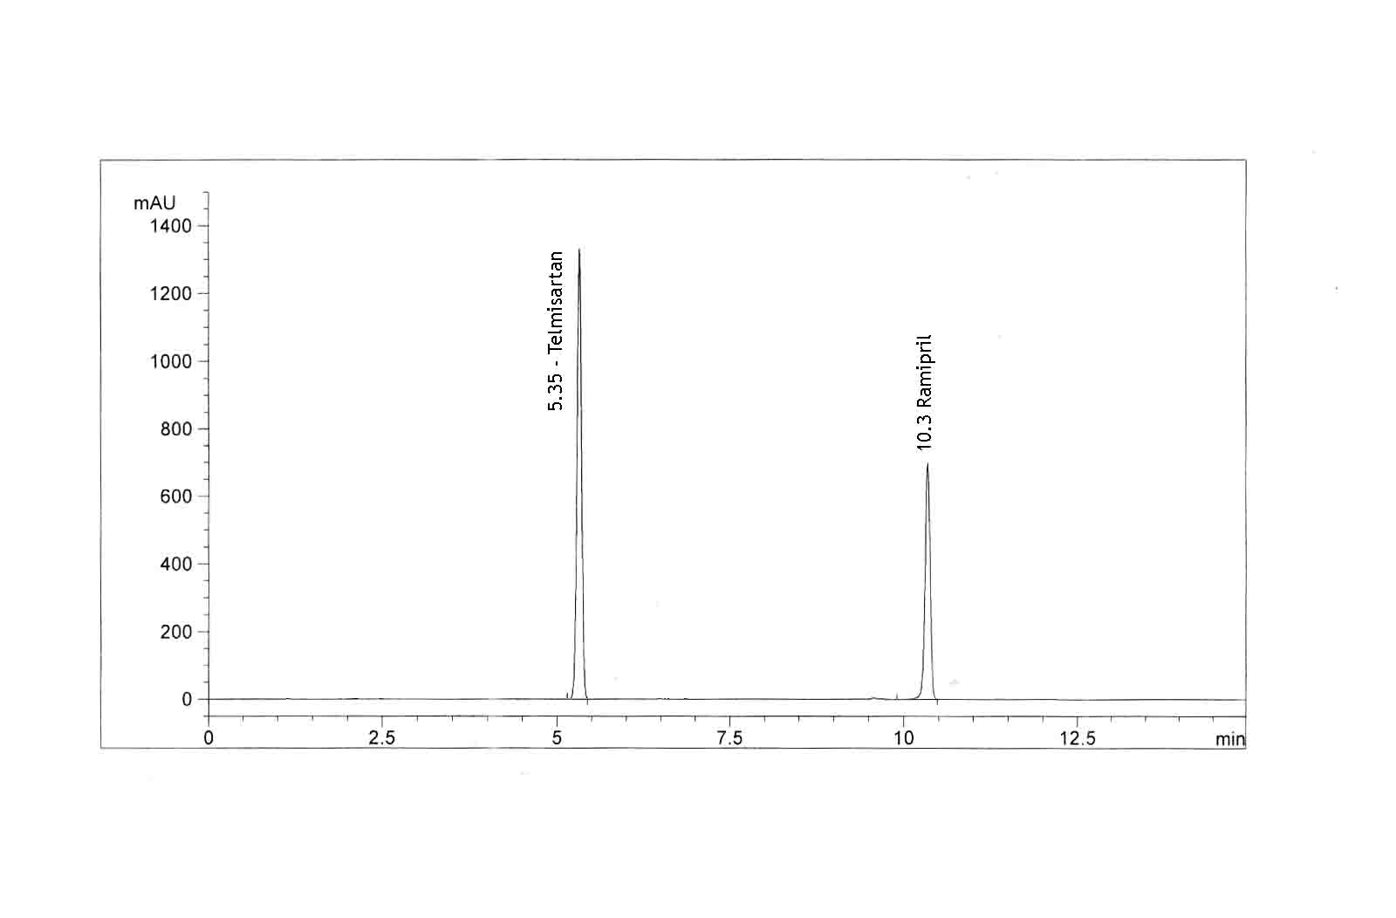

**Chromatogram of Recovery Studies at 15% Level**

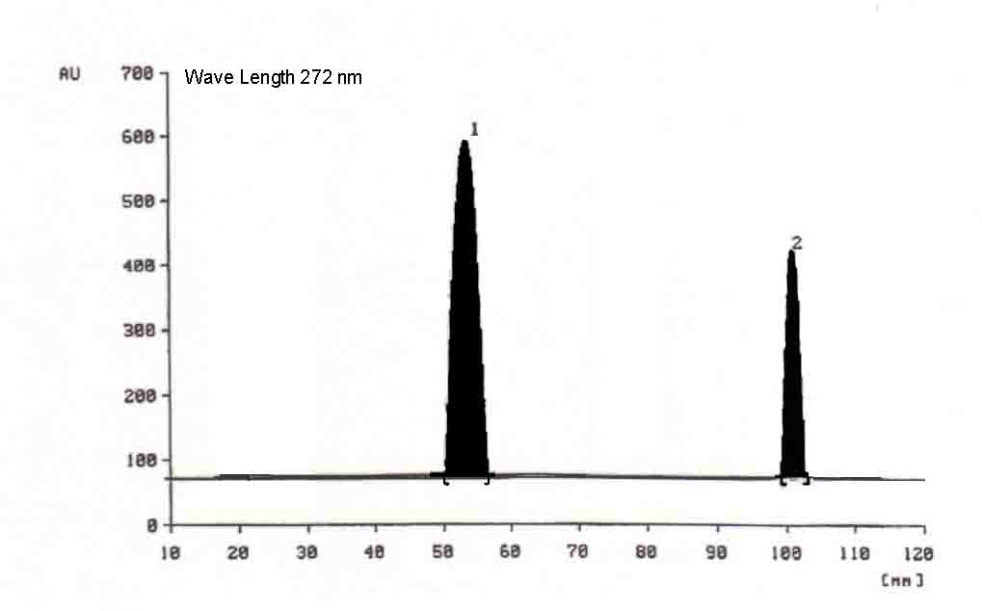



**Linearity of Telmisartan**

# 

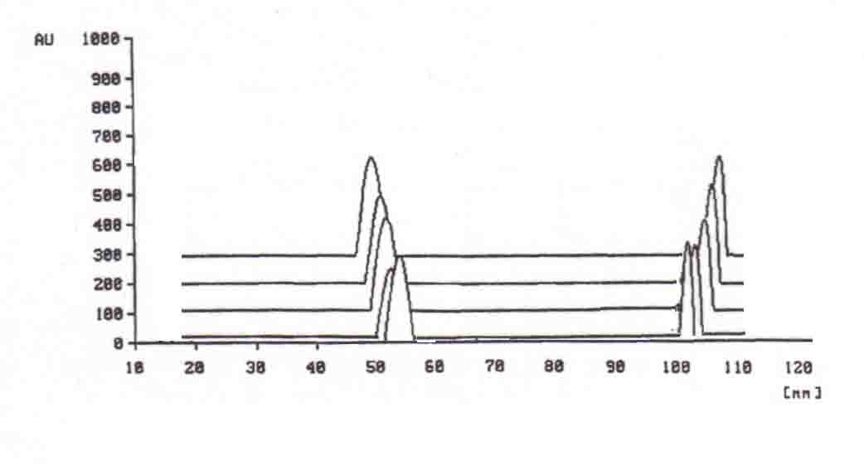

## Overlain densitogram for Linearity of Telmisartan and Ramipril

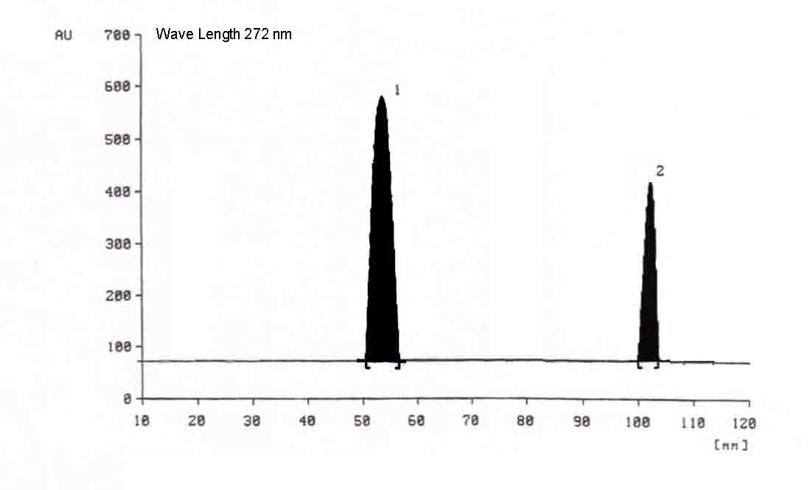

**Recovery Densitogram of Telmisartan and Ramipril**