**Development of Metoprolol Tartrate microspehere for Mucoadhesive Drug Delivery System**

**Figure:**

Figure-iCalibration curve of Metoprolol Tartrate in phosphate buffer pH 7.2.



**Figure-ii In vitro mucoadhesive strength determination of polymers**

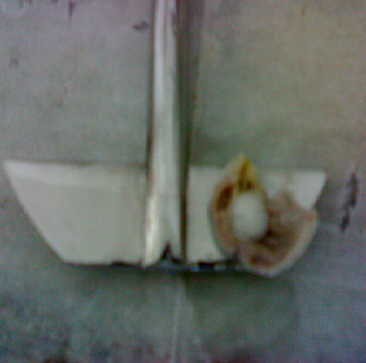

**Figure iii: Formulated microspehere**

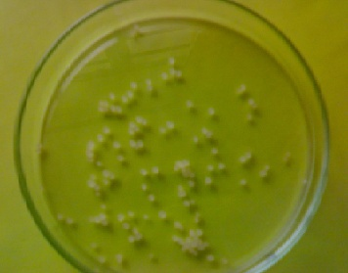

**Figure iv Bio adhesive strength by number method**



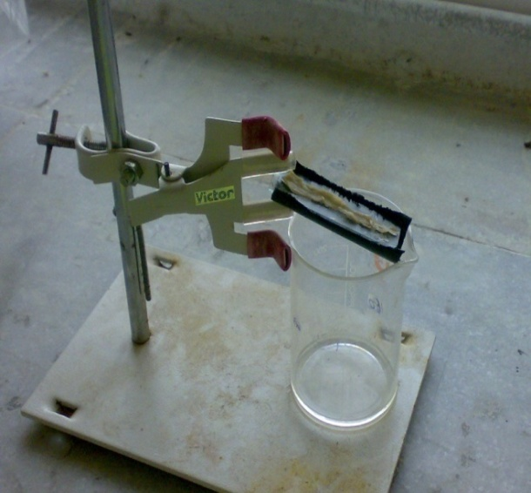

**Figure v Percentage drug release profile of metoprolol tartrate**

**Figure vi In Vitro Drug release in USP II (Paddle) Apparatus**

