A VALIDATED RP-HPLC METHOD FOR SIMULTANEOUS ESTIMATION OF TIROFIBAN HYDROCHLORIDE IN PURE AND MARKETED FORMULATION

FIGURES:

Fig. 1: Structure of Tirofiban Hydrochloride

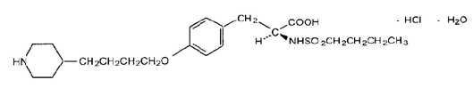

Fig. 2: Calibration curve of Tirofiban HCl showing linearity

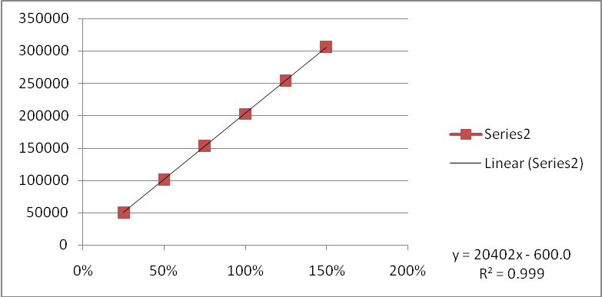
Calibration curve with Concentration on X-axis and Area on Y-axis

Fig. 3: Chromatogram of Tirofiban HCl standard

Tirofiban hydrochloride with t_{R} of 9.124 min.

Fig. 4: Chromatogram of market formulation of Tirofiban HCl
Tirofiban hydrochloride with t_{R} of 9.339 min.

