FORMULATION AND IN VITRO EVALUATION OF SUSTAINED RELEASE MATRIX TABLETS OF LORNOXICAM

Fig. No 1
IR Spectrum of Lornoxicam standard
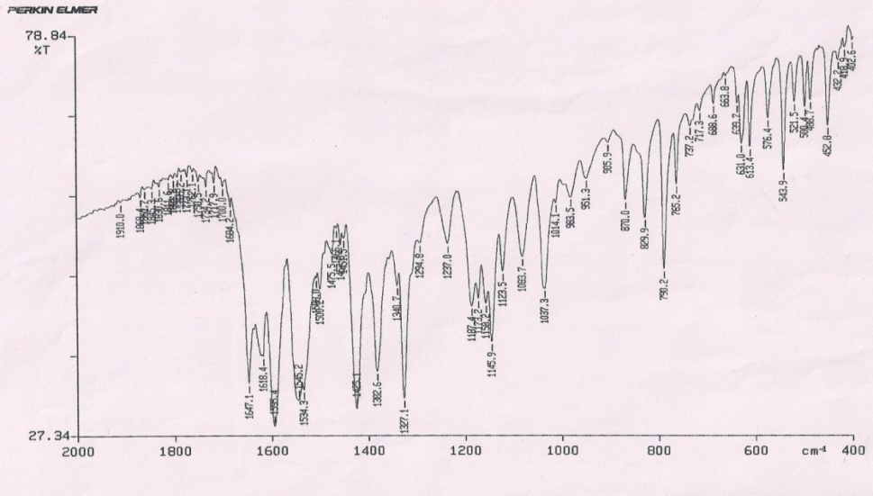
Fig. No 2
IR Spectrum of HPMC K 10 M
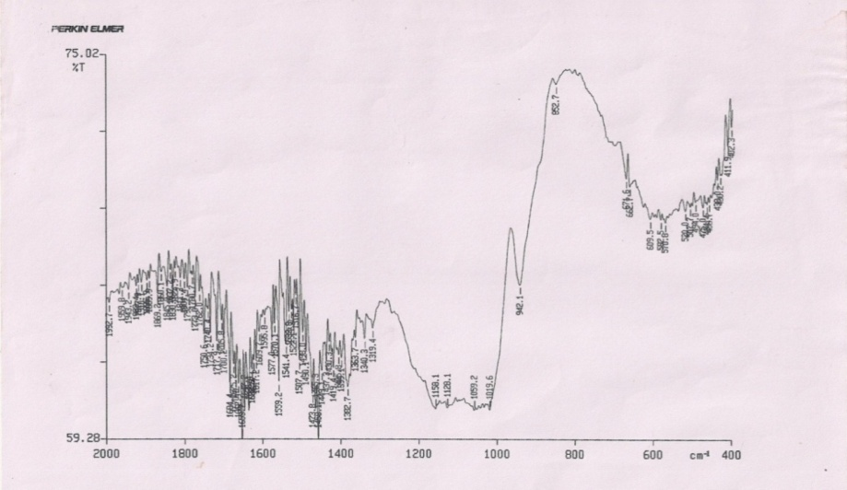

Fig. No 3
IR Spectrum of physical mixture
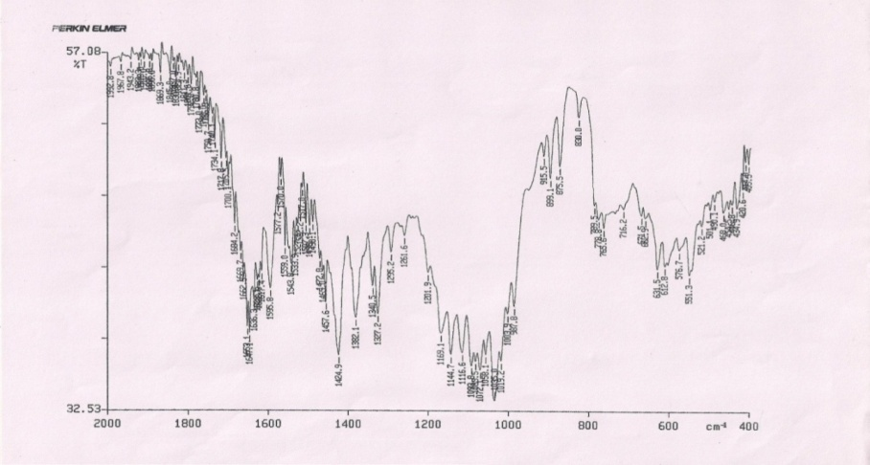
Fig No 4
In vitro drug release plot for formulations F₁- F₉

Fig No. 5
Zero order plot of F₉

Fig No. 6
First order plot of F₉

Fig No. 7
Higuchi plot of F₉

Fig No. 8
Korsmeyer peppas plot of F₉

