Figures:
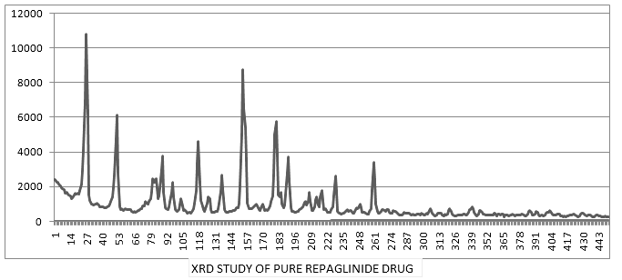
Figure 01: X-ray diffractograms of REPGLINIDE.
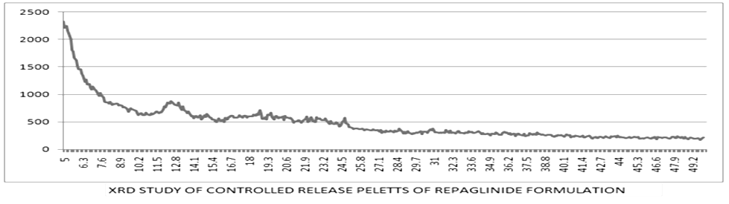
Figure 02: X-ray diffractograms of P1 controlled release pellets formulation of REPAGLINIDE.
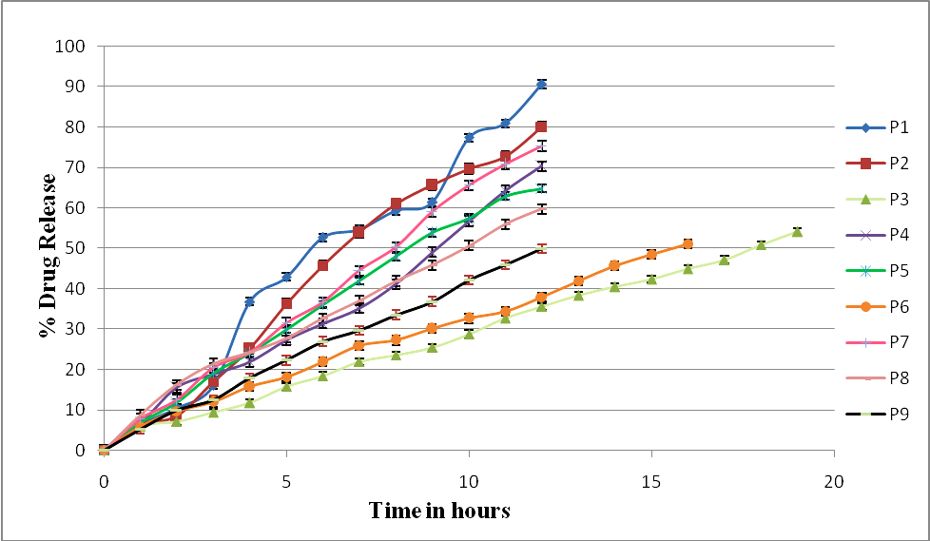
Figure 03: Drug release profile of Repaglinide from coated pellet formulations P1 to P9 (n=3), no. of experiments.
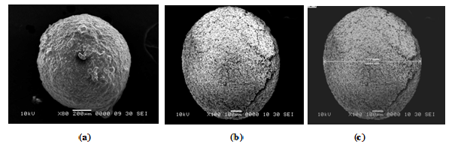Figure 04: Scanning electron microphotographs of pellets: (a), (b) & (c) surface morphology of uncoated pellets.
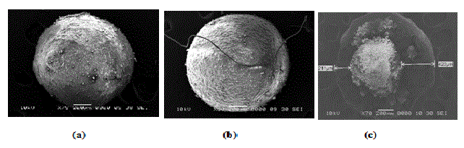Figure 05: Scanning electron microphotographs of coated pellets: (a), (b) smooth surface and (c) size range of coated pellets.
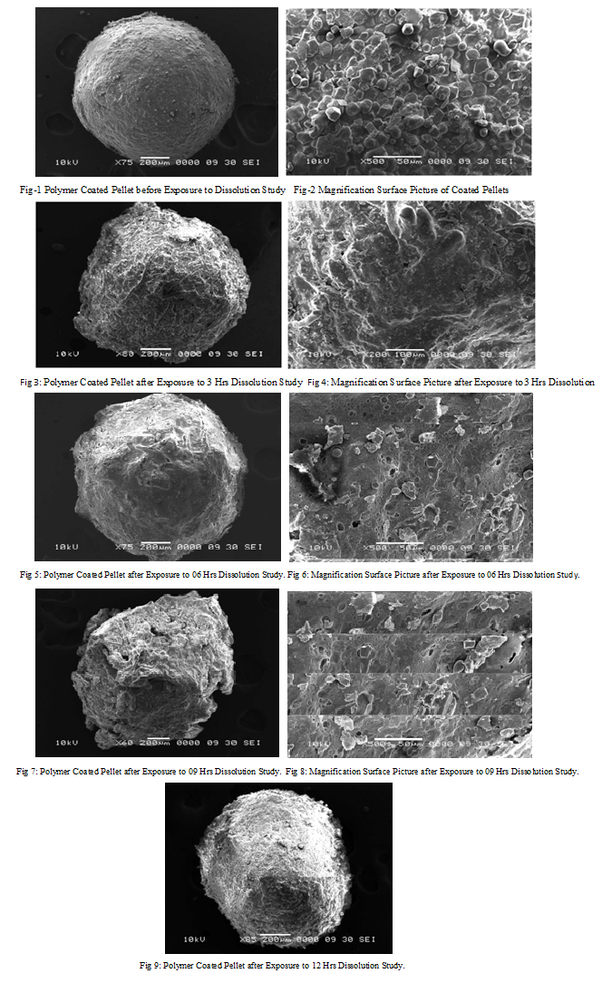
Figure 06: Scanning electron morphology study of coated pellets with specific time interval exposure to dissolution study. (1 to 9)
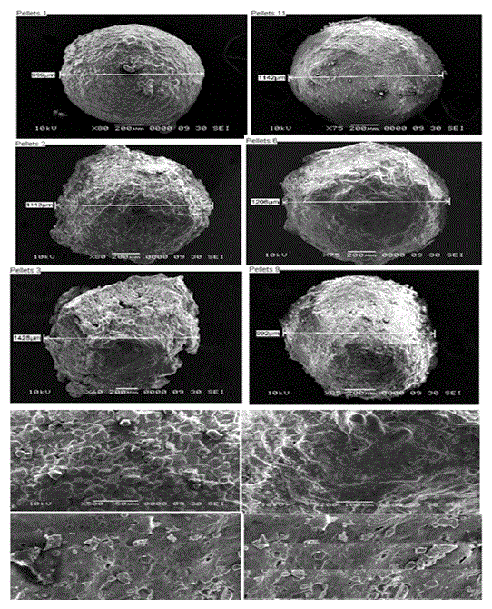
Figure 07: Scanning electron morphology study of coated pellets with decrease in diameter size after specific time interval exposure to dissolution study.
Figure captions:
Figure 01: X-ray diffractograms of REPGLINIDE.
Figure 02: X-ray diffractograms of P1 controlled release pellets formulation of REPAGLINIDE.
Figure 03: Drug release profile of Repaglinide from coated pellet formulations P1 to P9 (n=3), no. of experiments.

Figure 04: Scanning electron microphotographs of pellets: (a), (b) & (c) surface morphology of uncoated pellets.
Figure 05: Scanning electron microphotographs of coated pellets: (a), (b) smooth surface and (c) size range of coated pellets.
Figure 06: Scanning electron morphology study of coated pellets with specific time interval exposure to dissolution study. (1 to 9).
Figure 07: Scanning electron morphology study of coated pellets with decrease in diameter size after specific time interval exposure to dissolution study.

