Pharmacological Investigation of the Plant Prunus amygdalus (Batsch) for its Anti-ulcer
GSH determination

Graph-1 :- Bar chart of GSH determination in pylorus ligation induced ulcer
GWM determination

Graph-2 :- Bar chart of GWM determination in pylorus ligation induced ulcer
Hexosamine determination

Graph-3 :- Bar chart of Hexosamine determination in pylorus ligation induced ulcer
Catalase determination

Graph-4 :- Bar chart of Catalase determination in pylorus ligation induced ulcer
LPO determination

Graph-5 :- Bar chart of LPO determination in pylorus ligation induced ulcer
Determination of pH of Gastric Juice

Graph-6:- Bar Chart of pH Of Gastric Juice
Determintion of volume of Gastric Juice

Graph-7 :- Bar chart of volume of Gastric juice
Determination of Total Acidity

Graph-8 :- Bar Chart of Total Acidity of Gastric Juice
Determination of Ulcer Score

Graph-9:- Bar chart of ulcer score in pylorus ligation induced ulcer.

Morphology of Stomach in Pylorus Ligation Induced Ulcer
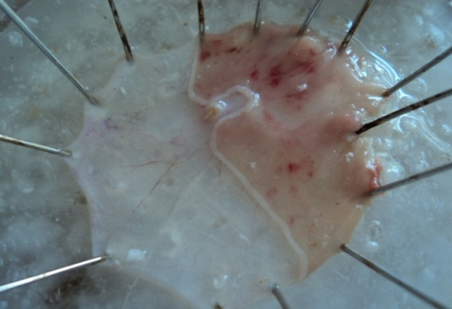 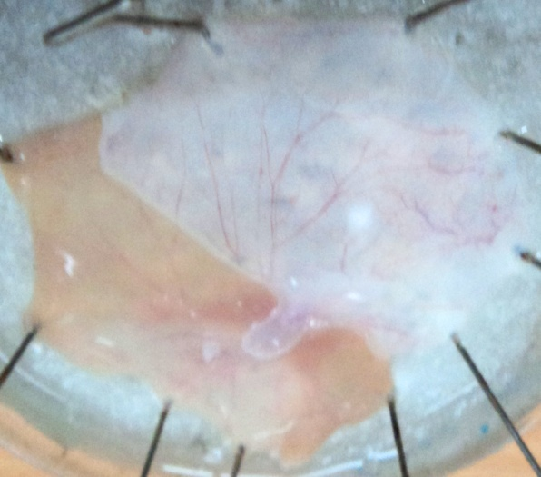Fig-1:-Negative Control Group Fig-2:- Standard Group
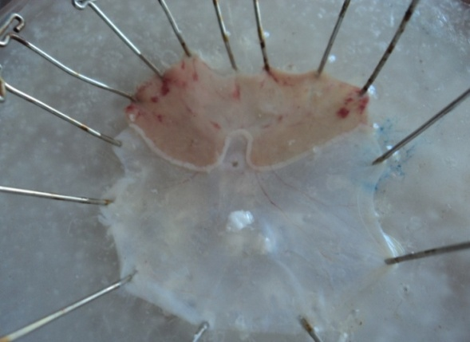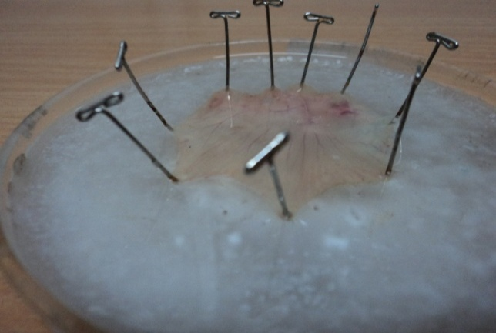
Fig-3:-200mg/kg P.A.E. Treated Group Fig-4:- 400mg/kg P.A.E. Treated Group

