Preparation and Evaluation of Fast Dissolving Tablets for an Selected Drug

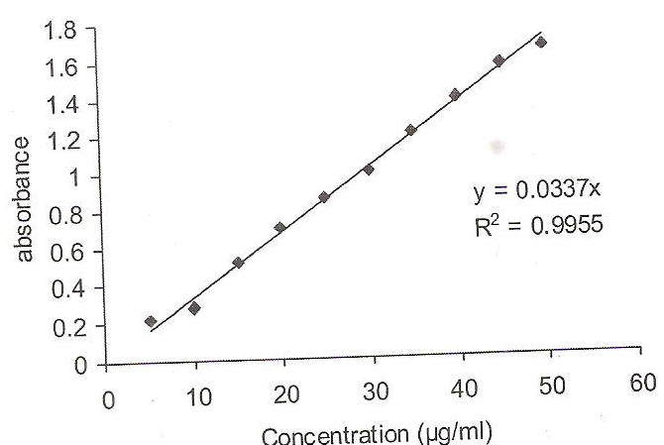

STANDARD CURVE OF DICLOFENAC SODIUM

IR Spectra-
I.R. spectra was obtained using KBr pellet method and compared with spectra as given in Indian Pharmacopoeia.
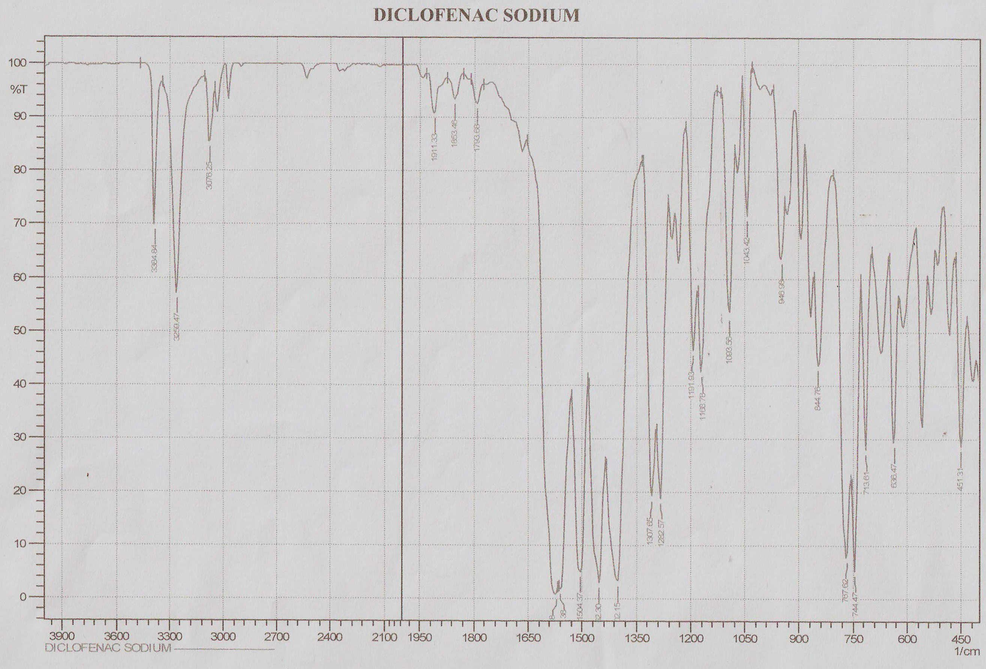

Drug release profile –
Y
X
Time(min.)

Y- % DRUG RELEASE
X- TIME(MIN.)

